Test data | Reason I chose data | What I expect to happen | What actually happened | What I changed
Clicking password checker | To check hyper links | Go ot password checker page | It went to password checker page | N/A
Clicking main | To check hyper links | Go to main | It went to main | N/A
Entered password | To check if it accepted something it should reject and that it allows inputs in password box | Return a red message telling me it contains password and that it contains lower case | 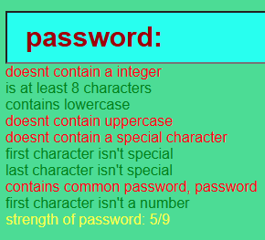 | N/A
Entered 123% | Checking it checks special character integers and starts with integer and length 8 | Return red message about first letter int and not 8 chars and a green contains integer and special | 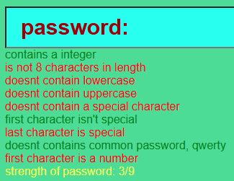 | N/A
Entered AbC% | Checking uppercase and last char special | Return green for upper and red for special last | 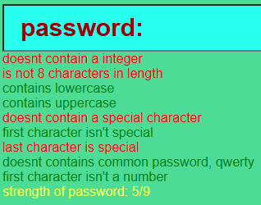 | N/A
Entered % | Checking first char special | Return red for special char first | 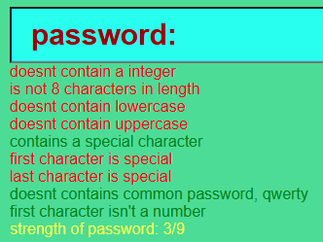 | N/A
Entered P1K@chu123 | Checking something that should send only green flags | Return only green flags | 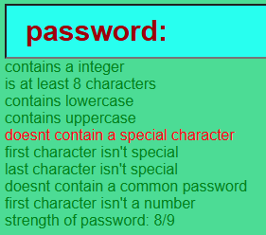 | Changed This '/[a-zA-Z0-9_]/' to this  '/[^a-zA-Z0-9_]/'

